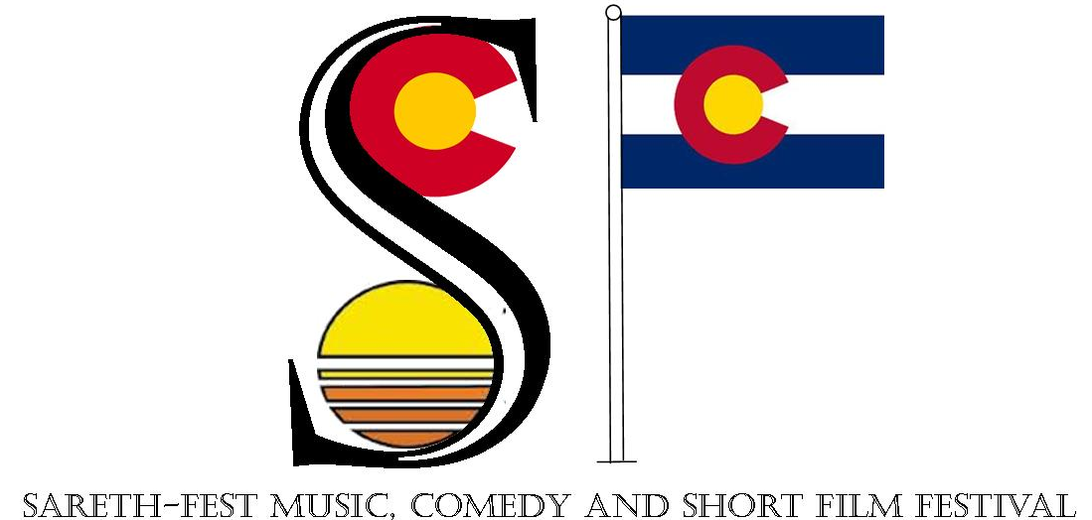
Director’s Name: ________________________________________________________
E-Mail Address: ________________________________________________________
Contact Number: _______________________________________________________
Title of Entry: __________________________________________________________
Genre of Music Video Entry: Hip-Hop ___ Multi-Genre ___ Rock ___
Genre of Short Film Entry: Comedy ___ Horror ___ Superhero ___
Synopsis: (100 Words Max):
______________________________________________________________________________________________________________________________________________________________________________________________________________________________________________________________________________________________________________________________________________________________________________________________________________________________________________________________________________________________________________________________________________________________________________________________________________________________________________________

Terms and Conditions:
- $10 submission fee for all motion pictures including music videos and short films.
- In order to be qualified for an award, each short film must include:
(One of the following venues, in some form or fashion):
  - Smitty’s Greenlight Tavern
  - The Damon Runyon Theater
  - First and Main Bar & Grill
  - J Michael’s Union Avenue Pub
  - Phil’s Bar and Music Venue
  - The Downtown Bar
  - The Daily Grind Café
  - It cannot be longer than 7 minutes and 19 seconds. All video and music clips must have permission for usage.
  - The following quote must be used in the short film, “Come with me and be immortal.”
- Music videos and short films must be uploaded to YouTube. Entries are accepted from July 4, 2015 through 11:59 p.m. MST of September 18, 2015. Please send the YouTube link(s) to Sareth Ney’s email at sareth.ney@aqdpi.com. Please email the submission form to sareth.ney@aqdpi.com, issue payment at aqdpi.com/sareth-fest-2015 or drop them both off at Damon Runyon Theater (611 North Main Street, Pueblo, Colorado 81003).
- Nominees for each category will be announced between September 28, 2015 and October 5, 2015 and one team member must bring a playable DVD of the video to the screening.
- There will be a total of four (4) nominees and there will be eight (7) categories. The winner of each category will be shown. Each director will receive one (1) ticket to attend the event and a +1, to bring a guest with them.
- The categories for the awards are: Best Comedy, Best Superhero, Best Horror, Best Hip-Hop, Best Rock, Best Multi-Genre and Best of Sareth-Fest (Viewer's Choice).
- All music videos are open for the musical acts on the Sareth-Fest bill and all short-film submissions are open to the general public.
- Judging will be based on how many views, how many thumbs up and how many thumbs down the video received on YouTube. Promote! Promote! Promote! Promote!
- One-of-a-kind statues will be sculpted by Pueblo artist, Vicente Martinez-Ortega.
- 100% of the proceeds will go to The Damon Runyon Theater to further advance the performing arts.

